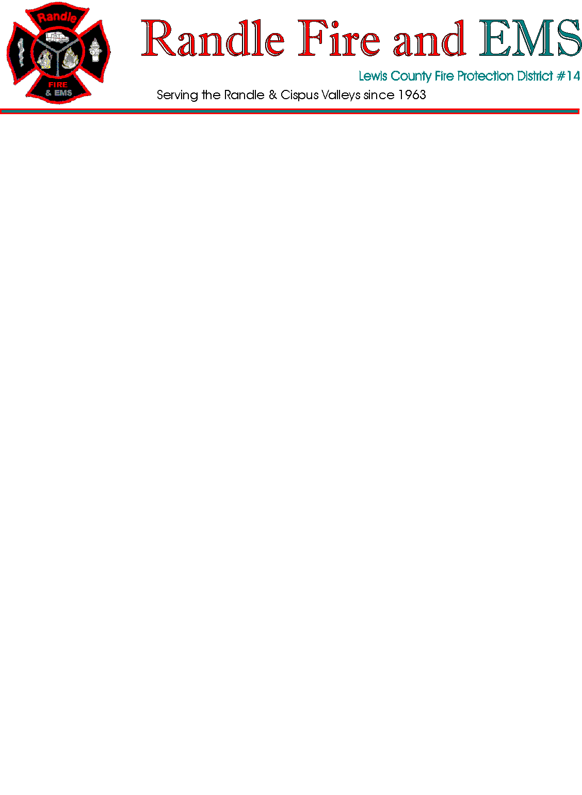
BOARD OF COMMISSIONERS
REGULAR BOARD MEETING
July 10, 2025 - Thursday - 5:30pm
Main Station - 9978 US Hwy 12, Randle WA

 |  | Call to Order and Flag Salute
 |  | Introduction of Arbor Health Guests
 |  | Additions/deletions-
1. |  | Approval of Agenda
2. |  | Approval of Expenditures |  |  |  | Expenditure List & Reimburse Voucher- current month
3. |  | Approval of Payroll
4. |  | Approval of Minutes |  |  |  | Previous month -
5. |  | GEN Financial Reports
6. |  | EMS Financial Reports + GEMT Totals
 |  | Umpqua Bank Checking
7. |  | Accounts Receivable – EMS Billing
 |  | GEMT Supplement/Payments Report
8. |  | Accounts Receivable – MVC Billing
9. |  | Correspondence
10. |  | Chief’s Report
11. |  | Unfinished Business
 |  | 1. |  | Ambulance- carry over until order is placed – Present V040 Project timeline
 |  | 2.
 |  | 3.
 |  | 4.
12. |  | New Business
 |  | 1. |  | Arbor Health
 |  | 2.  3.  4. |  | Resolution 2025-02 and policy approvals  Uniforms  SFY 2021-2023
 | Public Comments
 | Commissioners’ Comments

